## horizontal line



Irreversible Thermodynamics based approach to model flow stress behavior of Monel 400 alloy

30.04.2023

**─**

Supervisor: Dr. Surya Deo Yadav (Assistant Professor)

PhD Scholar: Mr. Nilesh Kumar

Department of Metallurgical Engineering,

IIT BHU, Varanasi

Adrija De

Roll No: 20144004

Department of Metallurgical Engineering,

IIT BHU, Varanasi

Table of Contents

Abstract 2

Introduction 3

Model Development 4

Dislocation Generation 5

Dislocation annihilation due to glide 6

Dislocation annihilation due to climb 7

Dislocation annihilation due to cross slip 7

Final Model 8

Model validation 9

Materials and Methods 14

Next steps 15

References 15

# 

# Abstract

Plastic deformation is a result of generation of dislocations and their consequent interaction with solute atoms or other dislocations. Mapping different dislocation mechanisms can help us produce a flow stress curve, eliminating the need of time-consuming experiments. This project aims to model a flow-stress curve of Monel 400 alloy, having composition 64.7 wt% Ni and 31.96 wt% Cu, using the irreversible thermodynamics approach. The model takes into account the change in entropy due to different dislocation mechanisms and other related long-range and short-range interactions. The flow stress behavior is modelled for two specimens of different grain size, each being deformed at five different temperatures and is validated by performing the appropriate experiments.

# Introduction

Monel 400 (64.7 Ni-31.96 Cu) is a single phase solid solution of nickel and copper having FCC crystal structure and can only be hardened by cold working[1]. Other strengthening mechanisms for Monel 400 include solid solution strengthening and grain size reduction. Its melting point lies in the range of 1300-1350 ˚C and it is a medium stacking fault energy (SFE) material. It is widely used in marine applications owing to its corrosion resistant properties. Pump and propeller shafts; electrical and electronic parts; springs; chemical processing equipment; petrol and fresh water tanks; crude petroleum stills, process vessels and piping; boiler feedwater heaters and other heat exchangers; and de-aerating heaters are some of its other applications[1]

Dislocations are line defects in a crystal lattice, resulting from the presence of extra half plane of atoms, which act as a boundary between slipped and unslipped region. The density of dislocations increases with the amount of deformation of the material. A dislocation’s magnitude and direction are defined by its burger vector, with edge dislocation having burger vector oriented perpendicular to the dislocation line and screw dislocation having burger vector oriented parallel to dislocation line. Their motion is governed by glide, climb and cross-slip to other slip planes. Three different mechanisms are usually responsible for plastic deformation to take place:

1. Dislocation generation due to Frank-Read sources
2. Dislocation glide on their slip systems
3. Dislocation Annihilation due edge dislocation climb and/or screw dislocation cross-slip

In this project, we have used the approach developed by M.Huang[2] which relates various dislocation mechanisms with the change in entropy of the system based on the concepts of irreversible thermodynamics. We have also incorporated effects due to twin boundaries as proposed by Alen et al. [3] and have integrated the constitutive equations from different sources. Since deformation is being done at temperatures greater than 0.5 Tm, recrystallization and recovery would play major role in grain growth and the equations corresponding to these mechanisms will be integrated later into the model. Also, although we have used Hall-Petch relation to model flow stress behaviour in the final flow-stress equation, other short-range order interactions would be more dominant at deformation temperatures higher than the equicohesive temperature (550-600 C for Monel 400). The model developed fits well to low-temperature deformation testing and needs to be further modified for high-temperature deformation testing (next step of the project).

# Model Development

According to the theory of irreversible thermodynamics, the degree of irreversibility can be measured by the entropy-increasing rate. Plastic deformation can be considered as an irreversible process and for a shear strain increment of dγ, we can consider the following equation for increase in internal entropy in the alloy as [2]:

$d_{i}S=\frac{1}{T}({dW}_{ge}+{dW}_{gl}$ ${+dW}_{an}$*) (1)*

Here, dWge, dWgl, and dWan are the dissipative energies due to processes of dislocation generation, glide and annihilation respectively, which are discussed above in the introduction; T is the deformation temperature as measured in the absolute scale.

The corresponding equations for dWge, dWgl, and dWan can be written as[4]:

$${dW}_{ge}=\left(\frac{1}{2}Gb2\right){dρ}^{+} (2)$$

${dW}_{gl}=\left(τbl\right){dρ}^{+}$*(3)*

${dW}_{an}=\left(\frac{1}{2}Gb2\right){dρ}^{-}$*(4)*

Here, the symbols have their usual meaning. G, b, τ and l represent shear modulus, burger vector, applied shear stress and mean glide distance respectively. ${dρ}^{+}{and dρ}^{-}$ are the number of dislocations generated due to Frank-read sources and number of dislocations annihilated due to climb/cross-slip respectively.

## Dislocation Generation

Frank-Read sources act as major source of dislocation multiplication, creating dislocations at a frequency f. The rate of generation of dislocations would be:

${\frac{dρ}{dt}}^{+}= ρ^{+}.f$*(5)*

The frequency can be written as the ratio of glide velocity (vg) to the mean free path of mobile dislocations until it encounters an obstacle(λ). Substituting in (Eq.5), we get:

${\frac{dρ}{dt}}^{+}= ρ^{+}.\frac{v_{g}}{λ}$*(6)*

We further know that the dislocation cell size (l) and the grain diameter(D) is related to the mean free path (λ) as [5]:

$\frac{1}{λ}=\frac{1}{l}+\frac{1}{D}$*(7)*

$$ρ^{+}v_{g}=\frac{M\dot{ε}}{b}$$

Using the well-known Orowan equation and (Eq.7), we finally get:

$$l=\frac{1}{√ρ}$$

${\frac{dρ}{dγ}}^{+}=\frac{1}{b}\left(√ρ+\frac{1}{D}\right)$*(8)*

as

Eq.8 gives the rate of generation of dislocations with respect to increment in shear strain due to Frank-read sources.

## Dislocation annihilation due to glide

Mobile dislocations will glide on application of shear stress and annihilate each other if negative edge interacts with positive edge dislocation or left-hand screw interacts with right-hand screw dislocation. Hence, it would be proportional to the interaction parameter Ω and dislocation density ρ as given by A.S. Joseph et al. [3]:

$$\frac{dρ^{-}}{dt}=Ωρ\frac{dε}{dt} (9)$$

Differentiating with respect to γ to maintain consistency in variables used,

$$\frac{d{ρ_{glide}}^{-}}{dγ}=\frac{Ωρ}{M} (10)$$

where $Ω_{0}$ and $Ω_{r0}$ are the calibration parameters and Dv is the diffusivity of the alloy at the specific temperature. This equation is also responsible for the dynamic recovery process at a high temperature. It should be kept in mind that this model will fail for very low plastic strain rate.

$Ω=Ω_{0}+Ω_{r0}{\left(\frac{MD_{v}}{\dot{γ}b2}\right)}^{\frac{1}{3}}$*(11)*

## Dislocation annihilation due to climb

Since Monel 400 is an alloy with medium SFE, the distance between the partial dislocations would be less, enhancing its tendency to climb due to static recovery. The equation for static recovery as developed by Nes et al.[6] :

$$ρ_{climb}^{-}=C_{sr}D_{v}\frac{Gb3}{kT}\left(ρ2-ρ_{0}2\right) (12)$$

$\frac{d{ρ_{climb}}^{-}}{dγ}={2C}_{sr}D_{v}\frac{Gb3}{kT}ρ\frac{dρ}{dγ}$*(13)*

Where Dv can be obtained from the Darken’s equation (Xi represents mole fraction of element i and Di represents diffusivity coefficient of element i).

$D_{v}=X_{Ni}D_{Cu}$ $+X_{Cu}D_{Ni}$*(14)*

## Dislocation annihilation due to cross slip

The higher the stacking fault energy (SFE), the lower the distance between two partial dislocations, thus aiding in the process of cross-slip. The equation governing the cross-slip in sub-grain interiors which leads to decrease in dislocation density is given by[7]:

$\frac{d{ρ_{cs}}^{-}}{dγ}=\frac{zυ_{D}}{\dot{γ}}exp⁡\left(-Aln\left(\frac{zυ_{D}}{2\dot{γ}}\right)+\frac{τV}{Gb3}\right)ρ$*(15)*

$$z=\frac{Gb4}{8πχV}$$

where ; $χ$ is the stacking fault energy and V is the activation volume, which is proportional to b3. It should be noted that this equation only applies to subgrain interiors and not sub-grain boundaries.

## Final Model

The total entropy change of the system can be written as the sum of entropy change due to dislocation mechanisms in the interior of the sample and entropy change due to energy dissipated as heat to the surrounding.

$dS=d_{i}S+d_{e}S$*(16)*

The entropy flux between the deformed metal and environment is given by[2]:

$d_{e}S$*= $\frac{Gb2}{2T}dρ-\frac{αGb√ρ}{T}$ (17)*

Combining Eqs (1),(16) and (17), we get:

$dS=\frac{1}{T}({dW}_{ge}+{dW}_{gl}$ ${+dW}_{an}$*) + $\frac{Gb2}{2T}dρ$ $-\frac{αGb√ρ}{T}$ (18)*

Substituting the values of dissipative energies for each dislocation mechanism:

$\frac{dS}{dγ}=\left(\frac{Gb2}{2T}\right)\frac{dρ_{ge}^{+}}{dγ}+\frac{τbl}{T}\frac{dρ_{glide}^{-}}{dγ}+\frac{Gb2}{2T}\left(\frac{dρ_{climb}^{-}}{dγ}+\frac{dρ_{cs}^{-}}{dγ}\right)+\frac{Gb2}{2T}\frac{dρ}{dγ}-\frac{αGb√ρ}{T}$*(19)*

Substituting the constitutive equations for each dislocation mechanism rate from Eqs (8), (10), (13),(15), and solving further, we obtain the final expression for $\frac{dS}{dγ}$:

$\frac{dS}{dγ}=\left(\frac{Gb2}{2T}\right)\frac{1}{b}\left(√ρ+\frac{1}{D}\right)+\frac{τbl}{T}\frac{Ωρ}{M}+\frac{Gb2}{2T}\left(2C_{sr}D_{v}\frac{Gb3}{kT}ρ\frac{dρ}{dγ}+\frac{zυ_{D}}{\dot{γ}}exp⁡\left(-Aln\left(\frac{zυ_{D}}{2\dot{γ}}\right)+\frac{τV}{Gb3}\right)ρ\right)$ $+\frac{Gb2}{2T}\frac{dρ}{dγ} -\frac{αGb√ρ}{T}$*(20)*

According to Nabarro’s concept, the entropy is related to the work hardening rate, and further substituting the values for work hardening rate, we obtain another equation for $\frac{dS}{dγ}$:

$\frac{dS}{dγ}=\frac{CαGb2}{2T}\frac{dρ}{dγ}$*(21)*

Equating equations (20) and (21), we finally obtain a differential equation in terms of dislocation density:

$\frac{dρ}{dγ}=\frac{\frac{(1-2α)√ρ}{b}+\frac{1}{bD}+2α\frac{Ωρ}{M}+\left(\frac{zυ_{D}}{\dot{γ}}exp⁡\left(-Aln\left(\frac{zυ_{D}}{2\dot{γ}}\right)+\frac{α√ρV}{b2}\right)ρ\right)}{\left(Cα-1\right)}$*(22)*

Solving the above differential equation, we would obtain the corresponding value of dislocation density (ρ), which can be inserted into the following equation to obtain flow stress:

$σ=σ_{HP}+MαGb\sqrt{ρ}$*(23)*

$G\left(T\right)=G_{0}-\frac{D_{G}}{(\exp\left(\frac{T0}{T}\right)-1)}$*(25)*

$σ=\frac{K_{HP}G(T)}{\sqrt{D}G(RT)}+MαGb\sqrt{ρ}$*(24)*

Where $σ_{HP}$ is the contribution due to Hall-Petch phenomenon, with KHP as the calibration parameter. The shear modulus is temperature sensitive as seen in equation (25); G(RT) is the shear modulus at room temperature.

# Model validation

The differential equation is solved using MATLAB (code mentioned in PPT). The parameters used for validating the model are mainly taken from A.S. Joseph et al.’s paper[3]. The parameters are also mentioned in the PPT along with their references.

Solving the model, we plot the flow stress for different grain sizes for deformation at 10-3/s strain rate at room temperature.

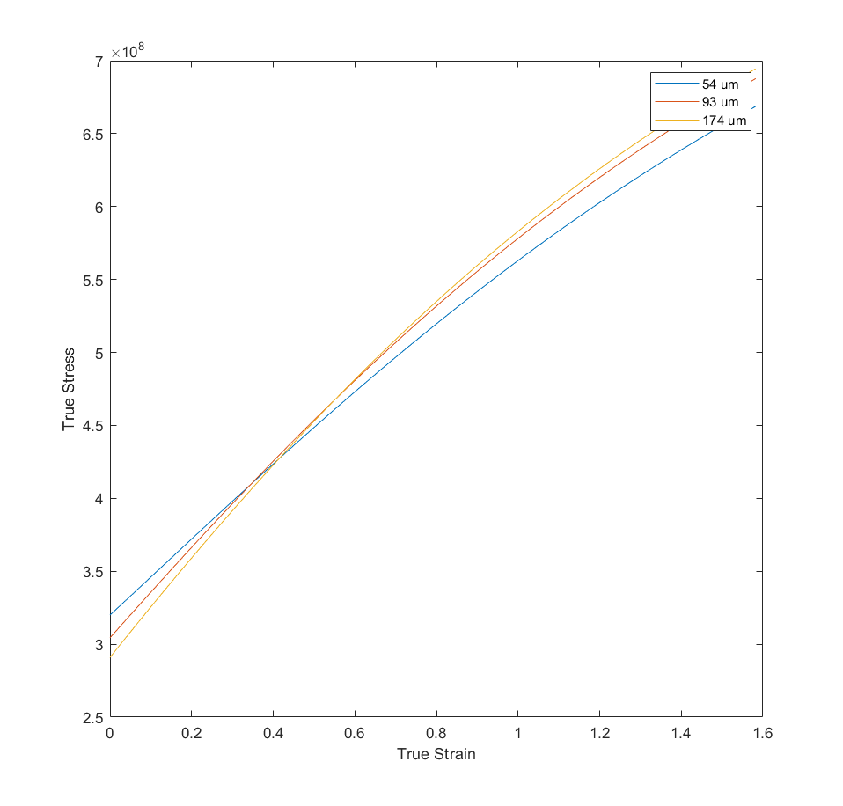

Fig 1. Flow stress curves for different grain sizes

Dislocation density increases with strain as expected during plastic deformation:

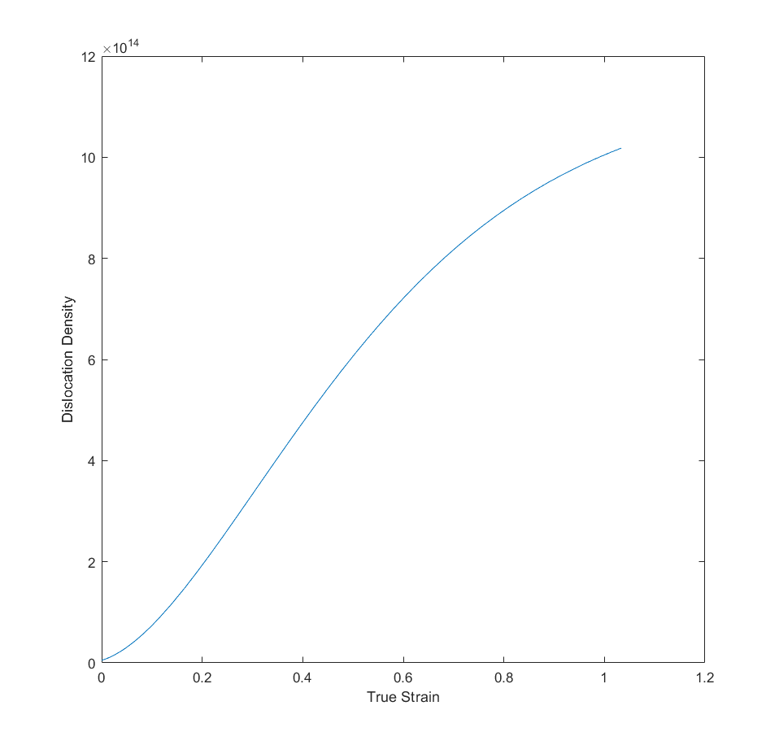

Fig 2: Dislocation density increases with true strain

Entropy of a closed system cannot decrease, but it is possible for the entropy of an open system to decrease under certain conditions.

In the context of the entropy change during plastic deformation of metals, it is important to consider that the system is not completely closed, but is instead an open system exchanging energy and matter with its surroundings. In this case, it is possible for the entropy of the system to decrease due to the heat flux towards the surroundings, even though dislocation generation, glide, and annihilation increase the entropy.

When a metal undergoes plastic deformation, dislocations are generated, glide, and annihilate, and this leads to an increase in the entropy of the system. However, at the same time, heat is generated due to the deformation, and some of this heat is conducted away from the system to the surroundings, leading to a decrease in the entropy of the surroundings. If the decrease in the entropy of the surroundings due to the heat transfer is greater than the increase in entropy due to dislocation activity, then the net change in entropy of the system and surroundings combined can be negative, leading to a decrease in the entropy of the open system.

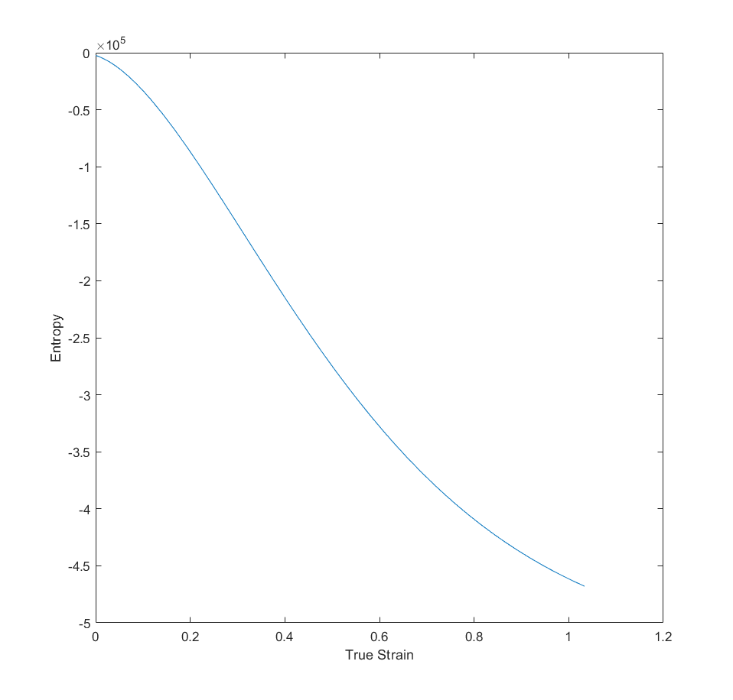

Fig 3: Entropy increases with increase in deformation

The model is fitted with experimental flow stress curves obtained for two different grain sizes (12 um and 93 um), which was obtained from the data retrieved from the paper by Gray et al. [8].

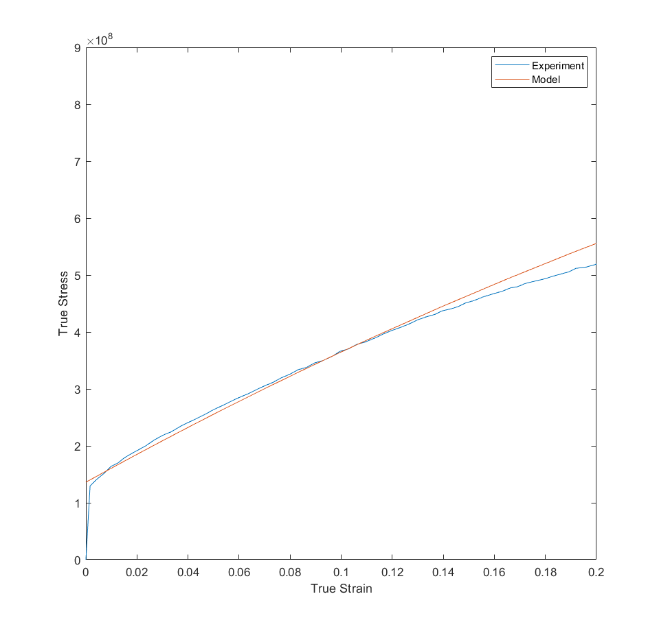

Fig 4: Flow stress curve at RT for grain size 93 um.

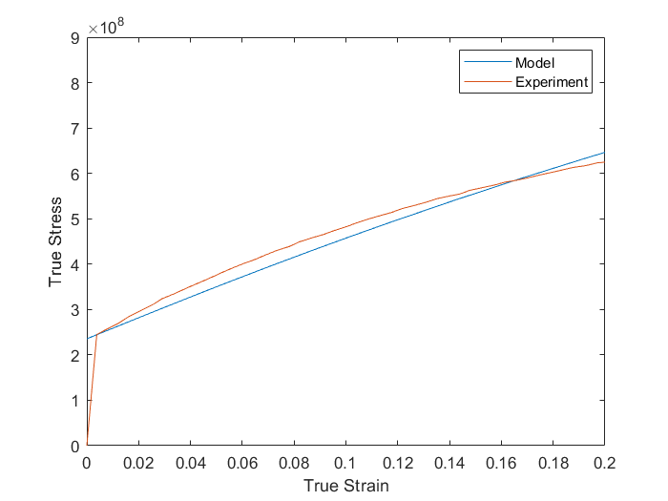

Fig 5. Flow stress curve at RT for grain size 12 um.

# Materials and Methods

To validate our model, we have decided to obtain flow stress curve for specimens having two different grain sizes and deformed at high temperatures. To decide the final grain sizes to be used for the experiment, we heat-treated five samples and observed their microstructures. The heat treatments were designed according to the data already available[1]. The sample was ground, polished and etched with solution containing 2g FeCl3 , 6 ml HCl, 24 ml water. The final microstructures selected are for samples having grain sizes 14.13 um ( Annealed at 760 C for 30 min and then, air-cooled) and 41.9 um (Annealed at 980 C for 8 min, and then, air-cooled).



Fig 6: 14.13 um effective grain size (Annealed at 760 C for 30 min and then, air-cooled)



Fig 7: 41.9 um effective grain size (Annealed at 980 C for 8 min and then, air-cooled)

# Next steps

Each sample would be deformed at temperatures of 650˚C, 700˚C, 750˚C, 800˚C, 850˚C. The experimental data thus obtained would be fitted to the model for its validation. This experiment could also have been completed, provided our department had a proper-functioning high temperature tensile testing machine.

# References

[1] “MONEL ® alloy 400.”

[2] M. Huang, P. E. J. Rivera-Díaz-Del-Castillo, O. Bouazizi, and S. Van Der Zwaag, “Irreversible thermodynamics modelling of plastic deformation of metals,” *Materials Science and Technology*, vol. 24, no. 4, pp. 495–500, Apr. 2008, doi: 10.1179/174328408X294125.

[3] A. S. Joseph, P. Gupta, N. Kumar, M. C. Poletti, and S. D. Yadav, “An advanced dislocation density-based approach to model the tensile flow behaviour of a 64.7Ni–31.96Cu alloy,” *Philosophical Magazine*, vol. 102, no. 15, pp. 1481–1504, 2022, doi: 10.1080/14786435.2022.2056645.

[4] M. Huang, P. E. J. Rivera-Díaz-del-Castillo, O. Bouaziz, and S. Van Der Zwaag, “Modelling strength and ductility of ultrafine grained BCC and FCC alloys using irreversible thermodynamics,” *Materials Science and Technology*, vol. 25, no. 7, pp. 833–839, Jul. 2009, doi: 10.1179/174328408X353750.

[5] L. E. Lindgren, Q. Hao, and D. Wedberg, “Improved and simplified dislocation density based plasticity model for AISI 316 L,” *Mechanics of Materials*, vol. 108, pp. 68–76, May 2017, doi: 10.1016/j.mechmat.2017.03.007.

[6] E. Nes, “MODELLING OF WORK HARDENING AND STRESS SATURATION IN FCC METALS.”

[7] H. Parvin and M. Kazeminezhad, “Two-internal variable thermodynamics modelling of severe plastic deformation: Dislocation and flow stress evolutions,” *Materials Science and Technology (United Kingdom)*, vol. 31, no. 14, pp. 1788–1793, Nov. 2015, doi: 10.1179/1743284715Y.0000000009.

[8] G. T. G. Iii, S. R. Chen, and K. S. Vecchio, “Influence of Grain Size on the Constitutive Response and Substructure Evolution of MONEL 400.”